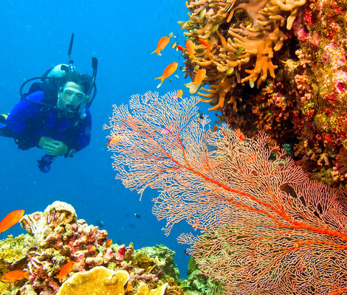

[Scuba Diving in Andaman](https://www.thrillophilia.com/tours/scubadiving-in-andaman)

NNNNN683 Ratings

h1 HourlHavelock Island

O~~3,999~~

Starting from

O3,599

[Send Enquiry](javascript:void(0);)

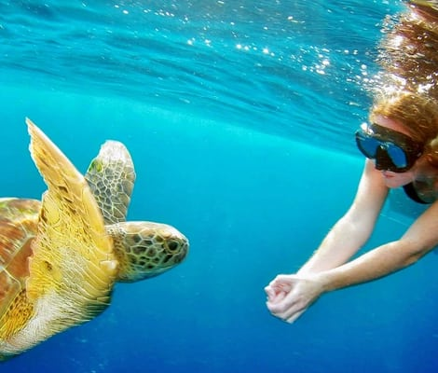

[Snorkeling in the Andamans](https://www.thrillophilia.com/tours/snorkeling-in-andamans)

NNNNN638 Ratings

lHavelock Island

Starting from

O1,850

[Send Enquiry](javascript:void(0);)

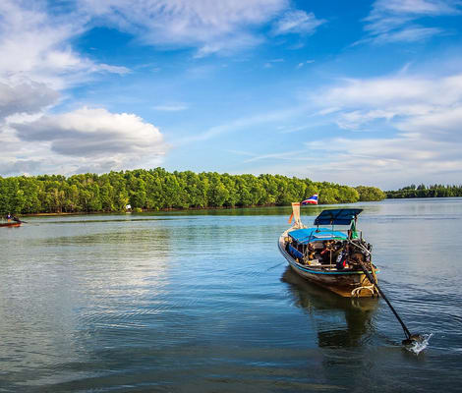

[Adventure at Baratang Island with Limestone Caves](https://www.thrillophilia.com/tours/adventure-at-baratang-island-with-limestone-caves)

NNNNN237 Ratings

h5 HourslBaratang Island

Starting from

O1,700

[Send Enquiry](javascript:void(0);)

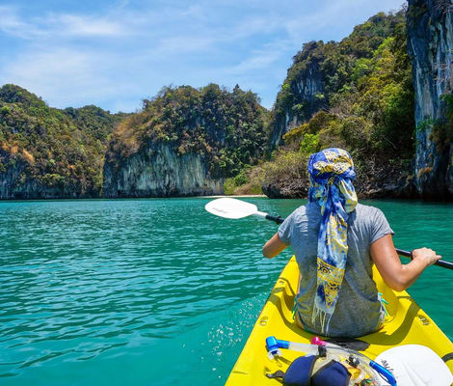

[Kayaking in Andaman](https://www.thrillophilia.com/tours/kayaking-in-andaman)

NNNNN216 Ratings

h2 HourslHavelock Island

Starting from

O3,500

[Book Now](https://www.thrillophilia.com/tours/kayaking-in-andaman?)

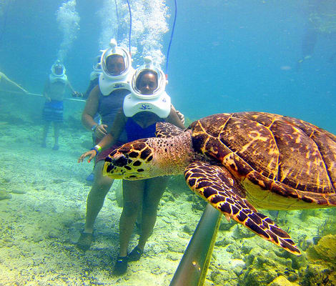

[Sea Walking at North Bay](https://www.thrillophilia.com/tours/sea-walking-at-north-bay)

NNNNN192 Ratings

lNorth Bay Island

Starting from

O3,500

[Book Now](https://www.thrillophilia.com/tours/sea-walking-at-north-bay?)

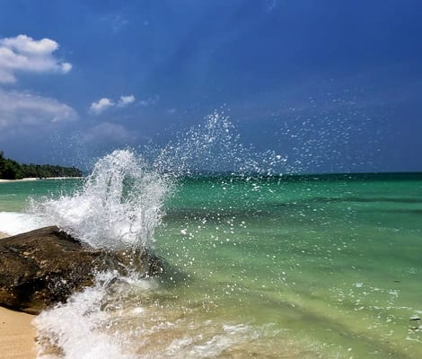

[Radhanagar and Kalapathar Beach Tour](https://www.thrillophilia.com/tours/radhanagar-and-kalapathar-beach-tour)

NNNNN201 Ratings

h5 HourslRadhanagar Beach

Starting from

O1,300

[Book Now](https://www.thrillophilia.com/tours/radhanagar-and-kalapathar-beach-tour?)

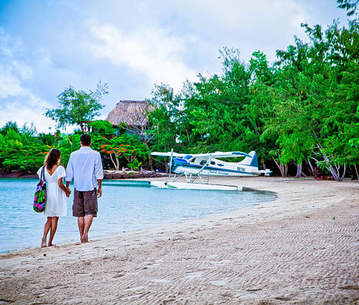

[Seaplane Ride from Havelock to Port Blair](https://www.thrillophilia.com/tours/seaplane-ride-from-havelock-to-port-blair)

NNNNN195 Ratings

h1 HourlHavelock Island

Starting from

O4,500

[Send Enquiry](javascript:void(0);)

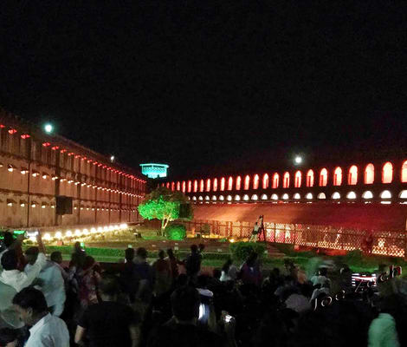

[Visit Cellular Jail and Watch the Light and Sound Show](https://www.thrillophilia.com/tours/visit-cellular-jail-and-watch-the-light-and-sound-show)

NNNNN698 Ratings

h8 Hours

Starting from

O700

[Send Enquiry](javascript:void(0);)

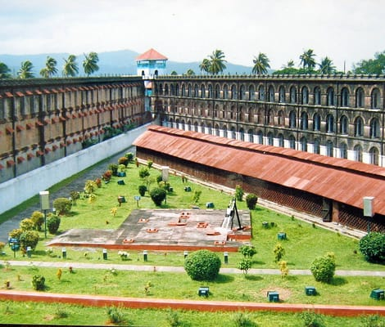

[Half Day City Tour with Chidhiyatapu](https://www.thrillophilia.com/tours/half-day-city-tour-with-chidhiyatapu)

NNNNN266 Ratings

h8 HourslPort Blair

Starting from

O1,800

[Book Now](https://www.thrillophilia.com/tours/half-day-city-tour-with-chidhiyatapu?)

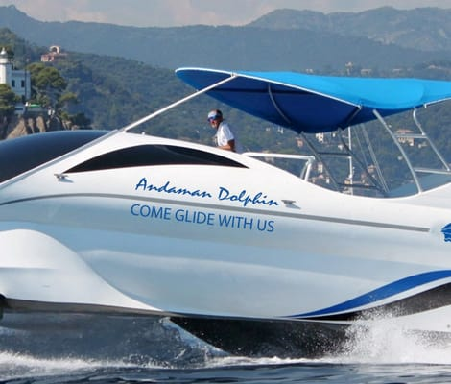

[Dolphin Glass Bottom Boat Ride in Andaman](https://www.thrillophilia.com/tours/dolphin-glass-bottom-boat-ride-in-andaman)

NNNNN194 Ratings

h1 HourlPort Blair

Starting from

O3,500

[Book Now](https://www.thrillophilia.com/tours/dolphin-glass-bottom-boat-ride-in-andaman?)

in Andaman.



[Adventure Trekking at Chidiyatapu](https://www.thrillophilia.com/tours/adventure-trekking-at-chidiyatapu)

NNNNN187 Ratings

h1 HourlChidiya Tapu

Starting from

O1,300

[Book Now](https://www.thrillophilia.com/tours/adventure-trekking-at-chidiyatapu?)